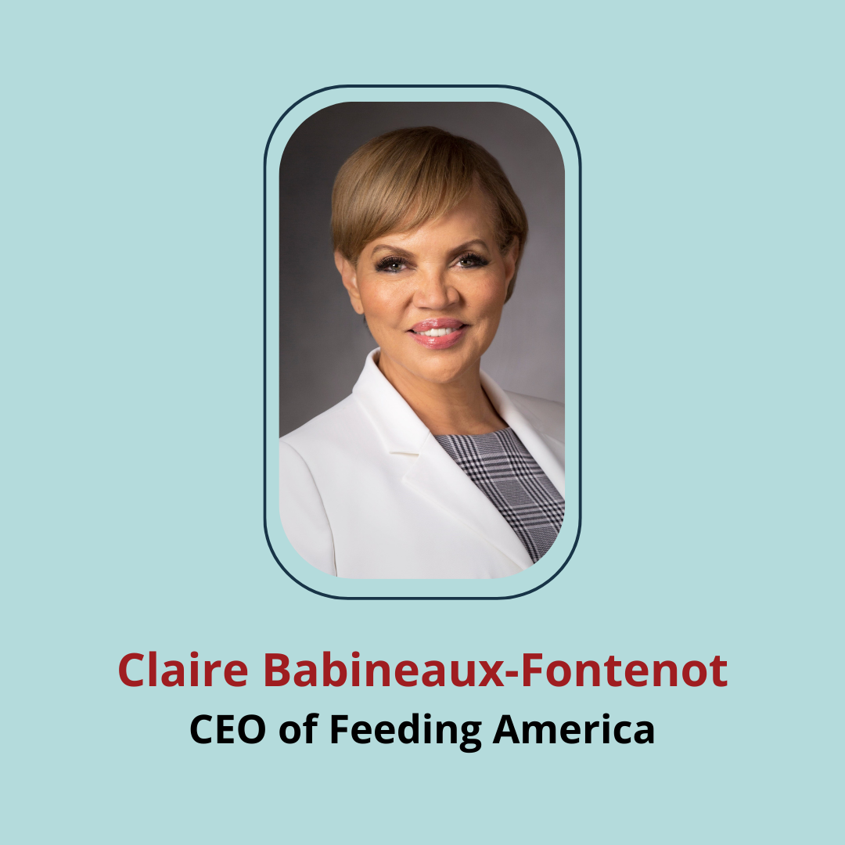

Claire Babineaux-Fontenot
CEO, Feeding America
Claire is chief executive officer of Feeding America, a nationwide network of 200 food banks and 60,00 food pantries and meal programs. Prior, she was executive vice president and global treasurer at Walmart, partner-in-charge of the Baton Rouge office and tax practice leader for Adams and Reese LLP, dispute resolution practice leader for the southwest region at PwC, and assistant secretary for the Office of Legal Affairs for the State of Louisiana.
Claire has served on boards such as Court Appointed Special Advocates for Children, Thurgood Marshall College Fund, National Urban League and National Association of Black Accountants.
Claire was named among TIME Magazine’s 100 most influential people in the world in 2020. She holds a Juris Doctor from Southern University Law Center in Baton Rouge and a Master of Laws in Taxation from Southern Methodist University Dedman School of Law in Dallas, Texas.
